QBUS5001
Q&A Lecture notes - Week 12

Part 0 – Administrative matters (Same as last week)

0.1 Group assignment is available now
Your group assignment will be available on 2:05pm 08/10/2024 via the link:
https://canvas.sydney.edu.au/courses/61229/assignments/549695

0.2 Nomination for Students' Choice Award for Teaching (Deadline 1 November 2024)
If you’ve found my teaching helpful, I would greatly appreciate your nomination for the Students' Choice Award for Teaching. This would not only benefit me but also help show others how unique and engaging a university classroom can be.

The nomination link is attached below:
https://forms-business.sydney.edu.au/teaching/students-choice-award-for-teaching

Here are the details you need to submit your nomination:


0.3 Nomination for 'Wayne Lonergan Award for Outstanding Leadership in Teaching' (Deadline 1 November 2024)
There’s another award, the Wayne Lonergan Award for Outstanding Leadership in Teaching, which also aligns with my work. It seems more complex, but if you feel I’m deserving, I’d love to give it a shot!
Here’s the nomination link:
https://forms-business.sydney.edu.au/teaching/WLOT-nominations
The same details are needed for the nomination: 

I truly appreciate your time and effort in the nomination process. Thank you in advance!

I truly believe we are witnessing history together! I never imagined things would unfold in such an incredible way, and none of this would be possible without your engagement and support. We’ve made a huge impact, not just within our classroom, but beyond it as well.

Together, we are making a real difference!

Part 0 - Understanding Multiple Linear regression model
Let’s have a look at how a population linear regression model generates data
$$Y=β_{0}+β_{1}X_{1}+β_{2}X_{2}+…+β_{k}X_{k}+ε$$

Population | Sample
Population regression equation | Estimated regression equation
Population slope coefficient | Sample slope coefficient
Population intercept | Sample intercept
Population error term | Sample residual

What is going to happen today?
The analysis of a multiple linear regression model is quite similar to that of a simple linear regression model. Today's lecture will be structured around problem-based learning, which I believe will be especially beneficial for your group assignments. We will align our approach with the marking rubric used for your assignments.

Criteria | Marks | Description
Stating the Full Model | 1 mark | Clearly states the full model, identifying dependent and independent variables.
Estimation of Full Model (with output in Appendix) | 1 mark | Correct model estimation with results shown in the appendix.
Correlation Analysis | 2 marks | Proper correlation analysis and discussion of the relationships between variables.
Final Model with Justification | 2 marks | Appropriate selection of the final model with clear justification for the variables chosen and excluded.
Overall Significance (F-test) | 2 marks | Correct execution and interpretation of the overall significance of the model using the F-test.
Individual Significance (t-tests) | 2 marks | Correct execution and interpretation of the individual significance of variables using t-tests.
Model Fit (R² and Adjusted R²) | 2 marks | Clear and accurate discussion of the model fit using R² and Adjusted R².
Testing Regression Assumptions | 4 marks | Thorough checking of regression assumptions (linearity, homoscedasticity, multicollinearity, normality).

This week, we will focus on four new concepts related to multiple linear regression (MLR). We'll explore each of them as we work through a complete MLR analysis in the example question:
- Dummy variables
- The 5th assumption – No multicollinearity
- Overall significance (F-test)
- Adjusted $R²$

Case study - Impact of Peer Support Programs and Other Factors on Graduate Salaries
The University of Sydney Business School is interested in understanding how peer support programs and other academic factors affect graduate salaries. You are provided with data that includes the graduate salary (in AUD) and various explanatory variables, including participation in peer support programs, study habits, and internship experiences. Your goal is to build a multiple linear regression model to analyse these factors.
Variables:
- Graduate Salary (AUD): The dependent variable representing the graduate's salary.
- PLG Regular Attendance (PLG): A dummy variable where:
  - 1 = Attended Peer Learning Groups (PLG) regularly
  - 0 = Did not attend PLG regularly
- PASS Regular Attendance (PASS): A dummy variable where:
  - 1 = Attended Peer Assisted Study Sessions (PASS) regularly
  - 0 = Did not attend PASS regularly
- Peer Mentoring Experience (Mentoring): A dummy variable where:
  - 1 = Worked as a peer mentor
  - 0 = Did not work as a peer mentor
- Attended Private Tutoring School (PrivateTutoring): A dummy variable where:
  - 1 = Attended external private tutoring school
  - 0 = Did not attend
- Weighted Average Mark (WAM): A numerical variable representing the student’s WAM (0-100 scale).
- Internship Length (months): A numerical variable representing the total length (in months) of internships completed during their studies.
- Average Study Hours per Week (StudyHours): A numerical variable representing the average number of study hours per week.
- Campus Coffee Consumption (Coffee): A numerical variable representing the average number of cups of coffee consumed per day.
- Attendance at Social Events (SocialEvents): A numerical variable representing the total number of social events attended during their studies.

New Knowledge 1 - Dummy variables
What are Dummy Variables?
- Dummy variables (also called indicator variables) are used in regression analysis to represent categorical data.
- They take on values of 0 and 1 to indicate the absence or presence of a certain category.

Why Use Dummy Variables?
- Regression models require numerical input, but categorical variables (e.g., gender, group membership) must be converted to a numerical form.
- Dummy variables allow us to include these categorical predictors in our models to understand their impact on the dependent variable.

Creating Dummy Variables
- For a categorical variable with two levels (e.g., biological gender: male or female), one dummy variable is sufficient:
  - Example: Gender = 1 for "Male", Gender = 0 for "Female"
- For a categorical variable with more than two levels (e.g., region: North, South, East, West), we create n-1 dummy variables (where n is the number of categories):
  - Example: For 4 regions, create 3 dummy variables (North, South, East), and the 4th category (West) will be the reference category.

Interpreting Dummy Variables in Regression
- Coefficient Interpretation: The coefficient for a dummy variable represents the difference in the dependent variable (e.g., salary) between that category and the reference group.
- Example: In a salary model with a "Peer Mentoring" dummy (1 = worked as peer mentor, 0 = did not work), the coefficient shows how much more or less salary someone who worked as a peer mentor earns compared to those who didn’t.

Important Notes
- Reference Category: The category not explicitly represented by a dummy variable is called the reference category, and all other dummy variables are compared to it.
- Avoid the Dummy Variable Trap: Never include all categories as dummy variables (e.g., if there are 4 regions, only include 3). Including all categories causes multicollinearity and makes the model unsolvable.

Example:
For a regression model predicting salary:
- PLG Regular Attendance (PLG): 1 = attended regularly, 0 = did not attend
- PASS Regular Attendance (PASS): 1 = attended regularly, 0 = did not attend
If the coefficient for PLG is 2000, it means attending PLG regularly leads to a $2,000 increase in salary compared to not attending.

Task 1 – Correlation Analysis

1.1 Why do we do correlation analysis?
1. Identify Relationships Between Variables:
- Correlation analysis helps us understand the strength and direction of the linear relationship between the dependent variable (e.g., graduate salary) and each independent variable (e.g., WAM, study hours). A high positive or negative correlation suggests that the variable might be a good predictor in the regression model.
2. Detect Multicollinearity:
- Correlation analysis helps identify multicollinearity, which occurs when two or more independent variables are highly correlated with each other (i.e., their correlation coefficient is near ±1). Multicollinearity can distort the regression results by making it difficult to determine the individual effect of each predictor on the dependent variable.
- No multicollinearity is a new assumption that is specific in multiple linear regression.

1.2 Correlation analysis in Excel
Data -> Data analysis -> Correlation
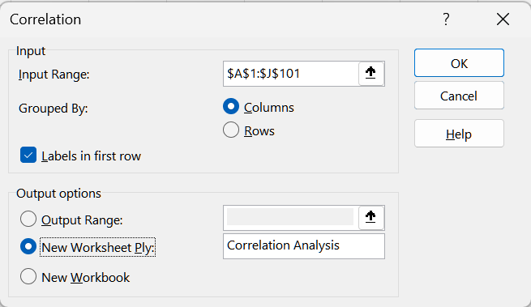
Click on “OK”

1.3 Output interpretation

Question 1:
It may seem that there is no strong correlation between graduate salary and any independent variable. Does this mean none of the variables are significant?

The short answer is no. There are several reasons for low correlations.

The data structure might be complex, and simple pairwise correlations can overlook this complexity. Regression allows us to test the simultaneous impact of all independent variables, meaning even low-correlation variables can be useful when considered alongside others.

Another reason could be the presence of dummy variables (e.g., attendance in a peer support program). Since dummy variables only take values of 0 or 1, they may not show a strong linear relationship in a correlation matrix, but they can still be highly important in the regression model.

There might be other reasons as well. You may explore more about it in your group assignment.

Question 2:
Does multicollinearity exist in this model?

High correlation coefficients (above 0.8 or 0.9) between independent variables indicate potential multicollinearity.

there are no immediate signs of high pairwise correlations (greater than 0.8 or 0.9), meaning that multicollinearity does not seem to be a major issue in this model, at least based on correlation analysis.

You can calculate the Variance Inflation Factor (VIF) for each independent variable to get a more detailed understanding of multicollinearity. (Do you own learning if you like to include it in your group assignment)

Task 2 – Model estimation and interpretation
Here is the regression output by
Data -> Data analysis -> Regression
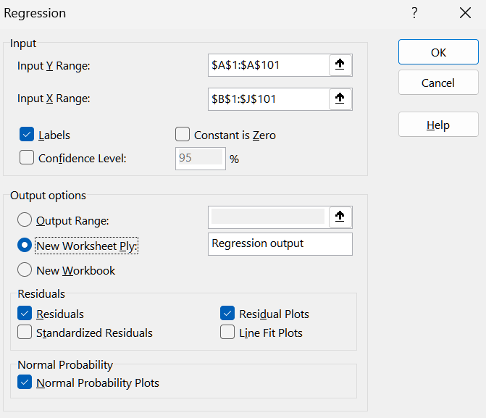
And then click on “OK”
Questions:
  - Write down the multiple linear regression model
Let $Y$ be the Graduate Salary in AUD
Let $X_{1}, X_{2},…, X_{9}$ be the independent variables PLG, PASS, Mentoring, PrivateTutoring, WAM, Internship, StudyHours, Coffee, and SocialEvent, respectively.
So the full model is given by
$$Y=β_{0}+β_{1}X_{1}+β_{2}X_{2}+…+β_{9}X_{9}+ε$$

  - Write down the estimated regression equation
The estimated regression equation is given by
$$\hat{Y}=66800.30+2481.78X_{1}+2069.94X_{2}+2835.42X_{3}-2209.32X_{4}-8.85X_{5}+1099.95X_{6}+149.34X_{7}+102.30X_{8}-82.80X_{9}$$

  - Interpret the estimated coefficients of Internship and Mentoring.
For each additional month of internship experience, holding all other variables constant, the graduate salary is expected to increase by $1,099.95.

If a graduate used to work as a peer mentor (Mentoring = 1), their salary is expected to be $2,835.42 higher than graduates who did not work as a peer mentor (Mentoring = 0), holding all other variables constant.

Task 3 – Model valuation and refinement
There are 3 tools in your toolbox for model valuation:

  - Find the coefficient of determination ($R²$) and the adjusted coefficient of determination (adjusted $R²$). Explain why adjusted $R²$ is a better measure in multiple linear regression.

  - Does the regression model, with all independent variables considered together, make a statistically significant contribution to explaining the variation in $Y$?

  - Based on the individual significance t test, which of the independent variables are significant and which are not?

  - Now, imagine we removed the insignificant independent variables one-by-one, and here is the latest output. Discuss if the model has been improved or not?

Task 4 – Model Assumptions
Do you still remember the
L.I.N.E
What does each letter stand for?

This week, we have a new assumption: No Multicollinearity
In multiple linear regression, the assumption of no multicollinearity means that the independent variables should not be highly correlated with each other. Multicollinearity occurs when two or more independent variables are closely related, making it difficult for the model to isolate the effect of each variable on the dependent variable.

Why is it important?
- Inflated standard errors: Multicollinearity can cause the standard errors of the regression coefficients to increase, leading to less reliable estimates.
- Unstable coefficients: It becomes harder to determine the individual effect of each predictor variable, making the coefficients highly sensitive to small changes in the data.
- Misleading significance: Variables that are actually important may appear insignificant due to the inflated standard errors.

How to detect it:
- Correlation matrix: Look for high correlations (above 0.8 or 0.9) between independent variables.

